Task: Your task is to make a system for Restaurant Bill Management.

1. Create a class named Restaurant that contains some members that are given below. **10**

Restaurant

{

int food_item_codes[12];

string food_item_names[12];

int food_item_prices[12];

int total_tax;

}

Give the access modifiers as your needs.

1. Take input of all food_item_codes, food_item_names and food_item_prices. Input is given below. **10**

12

170

Chicken Soup 1:2

260

171

Chicken Corn Soup 1:2

200

172

Thai Special Soup 1:2

300

260

Chicken Fried Rice 1:2

250

261

Egg Fried Rice 1:2

230

262

Prawn Fried Rice 1:2

300

310

Beef Mutton Kabab 1:1

150

311

Chicken Grill 1:4

340

450

Chicken Curry 1:3

550

451

Beef Special Curry 1:3

760

452

Chicken Sizzling 1:3

710

453

Beef Sizzling 1:3

970

1. After taking input the system will start working. You need to show all food_item_codes food_item_names and food_item_prices in a decent way. The demo is given below. You don’t need to make it exactly like this, you can make it in your own way. But it must look nice. **20**

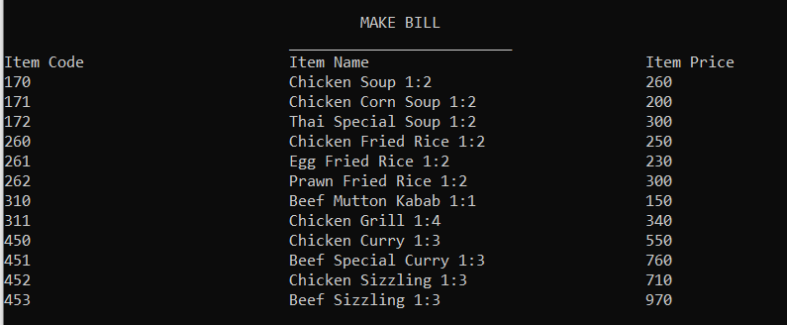

1. Now take some inputs from the user. You need to take the table number of the customer, and the number of items the customer has taken as input. After that, take all the item's code and quantity as input. **10**

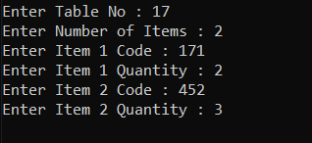

1. As you know the codes of food items, you need to find which code belongs to which food item. Then you need to show the table number, food item's code, name, price, quantity, and the total price of that food item. **15**
2. At last calculate the tax amount that is 5% of the total amount. And last show the net total that is the sum of tax and total amount. **15**

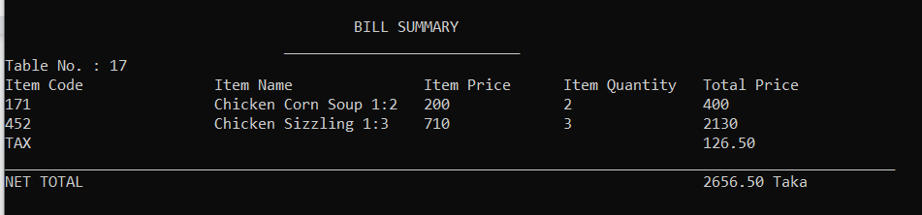

1. Finally add this tax amount to the total_tax of the Restaurant class. **10**
2. When the user takes input of the food item’s code, if the item is not available then you need to tell the user that this code is not valid, he/she needs to enter the code again. **10**